Preliminary Project Report
Client: University of Iowa (Paloma Giangrande)
November 9, 2016

Aaron Martin

Introduction
The project objective was to determine kinetic rate and equilibrium dissociation constants for RNA aptamers binding immobilized H4 Histone and Histone from Calf thymus. SensíQ Pioneer FE was used to capture both histone proteins on respective flow channels and test binding of three specific aptamers and one negative control aptamer. A regeneration method using 1M NaCl was tested and shown to give reproducible responses after multiple binding-regeneration cycles.

Methods

SensíQ Pioneer FE was used for SPR analysis with an assay buffer containing 10 mM HEPES pH 7.4, 150 mM NaCl, and 2 mM CaCl₂.

Immobilization of Histone Proteins
pH scouting was performed with both proteins and it was found that H4 Histone preconcentrated to a COOHV biosensor optimally at pH 4.7 and Calf thymus histone at pH 6.0. To prevent non-specific binding to the vial and sensor surface a small concentration (~0.01%) of Tween-20 was added to these solutions. The proteins were immobilized following a standard amine coupling procedure where a mixture of EDC and NHS was injected to activate the surface carboxyl groups and protein was injected to react with and be coupled to the sensor surface. 1M Tris pH 8 was injected last to deactivate remaining active carboxyl groups.
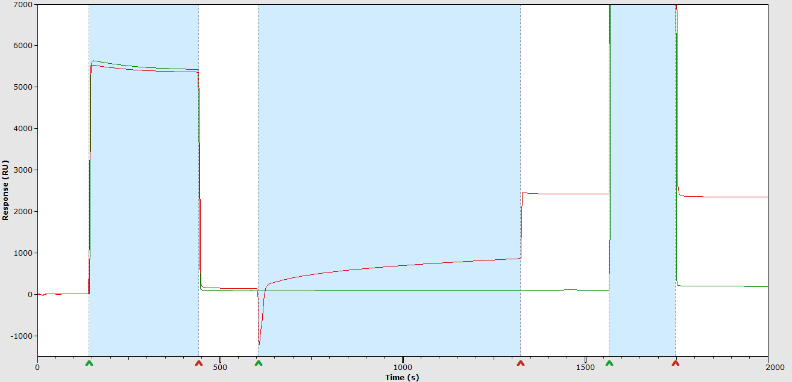
Figure 1 – Immobilization of H4 Histone. Channels 1 and 2 are illustrated in red and green curves. Injections are shown in highlighted. Activation with EDC/NHS was first, H4 Histone in pH 4.7 Acetate buffer was second, and 1M Tris (cropped) was the third injection.
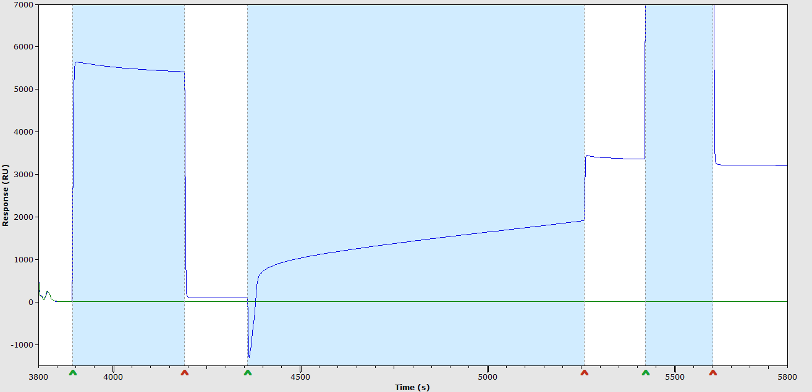
Figure 2 – Immobilization of Calf thymus Histone. Channels 2 and 3 are illustrated in green and blue curves. Injections are shown in highlighted. Activation with EDC/NHS was first, Calf thymus Histone in pH 6.0 Acetate buffer was second, and 1M Tris (cropped) was the third injection.
Approximately 2500 response units (RU) of H4 Histone and 3000 RU of Calf thymus histone were immobilized on respective flow channels. Channel 2 was activated and deactivated to serve as a reference.

Kinetic Assay
A dilution series was prepared for each aptamer in buffer to make: 100, 50, 25, 12.5, and 10 nM. Each sample was injected over all three flow channels for 4 min at a flow rate of 30 µL/min and dissociation was monitored for 10 min. The sensor surface was regenerated after each analyte cycle by injecting 1M NaCl for 1 min. Data were processed by subtracting the reference channel signal and buffer blank responses (double referencing method). A two compartment kinetic (mass transport limited) model was fit to the data to determine rate constants of association (k_{a}) and dissociation (k_{d}). A local Rmax was provided in the fit due to an apparent concentration-dependent surface activity.

Experimental Results & Discussion
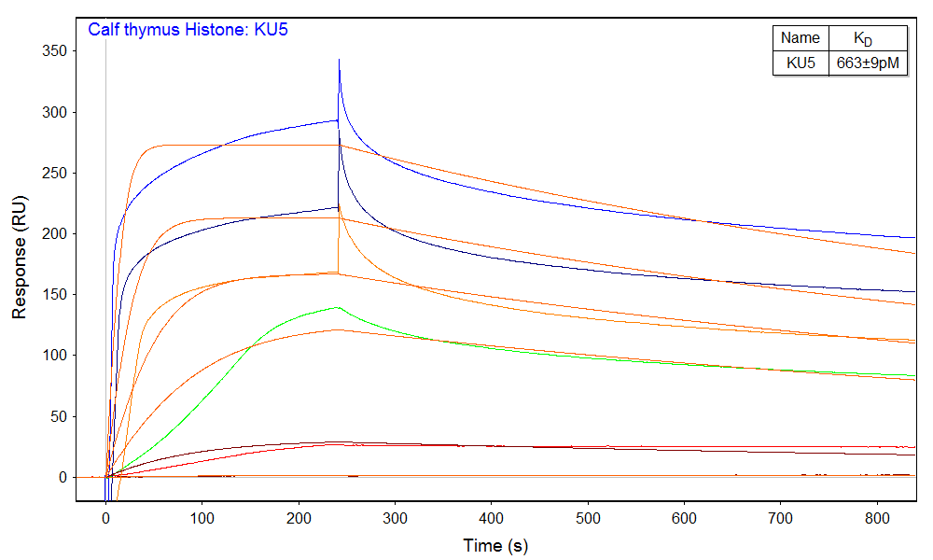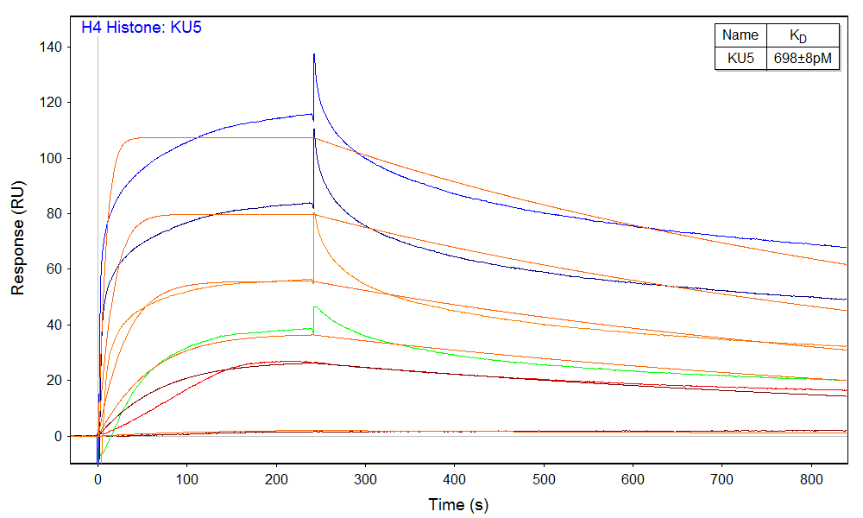
Figure 3 – Kinetic analysis of KU5 binding calf thymus Histone (left) and H4 Histone (right).
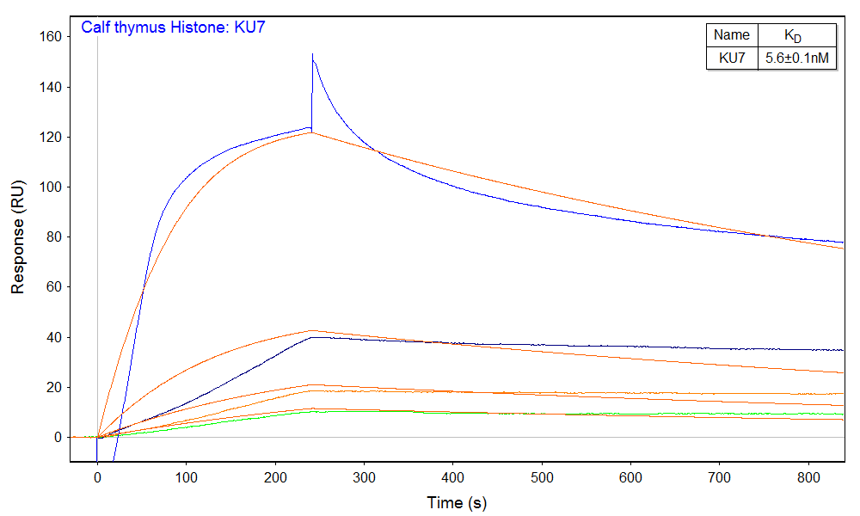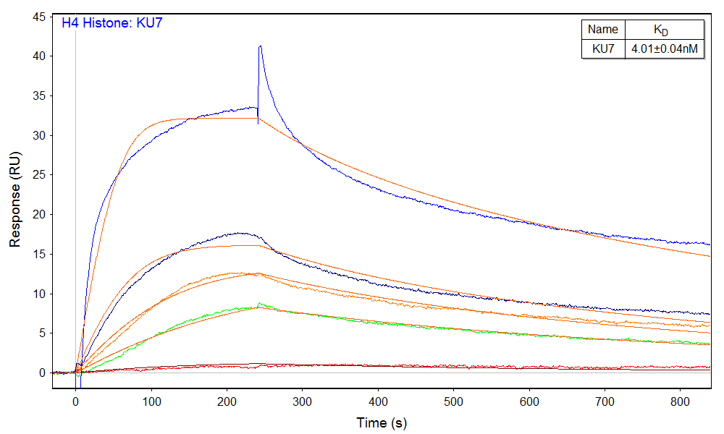
Figure 4 – Kinetic analysis of KU7 binding calf thymus Histone (left) and H4 Histone (right).
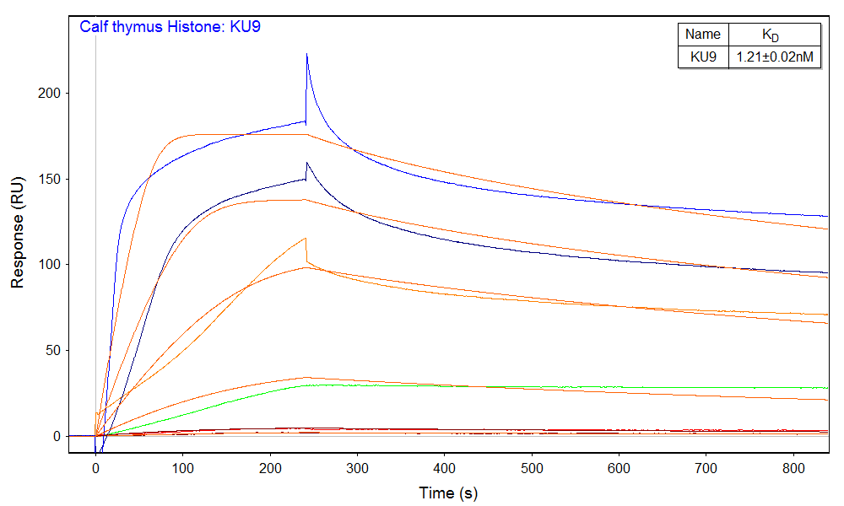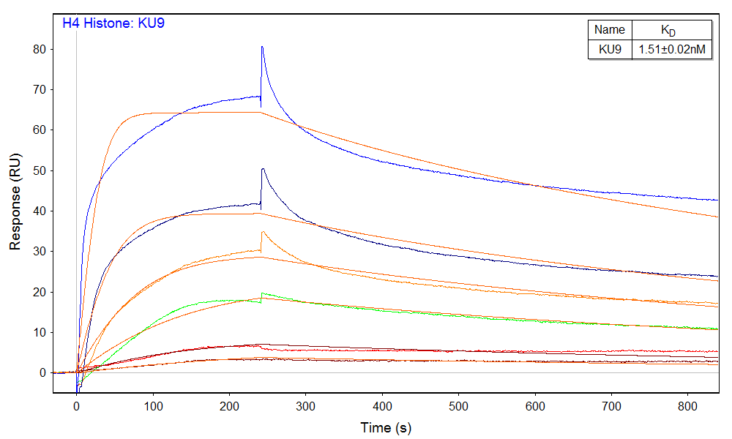
Figure 5 – Kinetic analysis of KU9 binding calf thymus Histone (left) and H4 Histone (right).
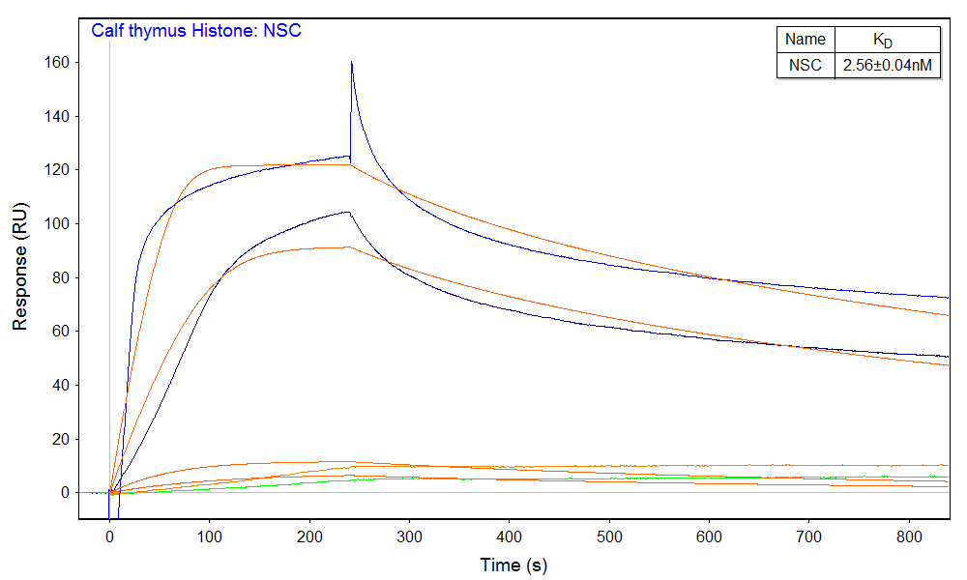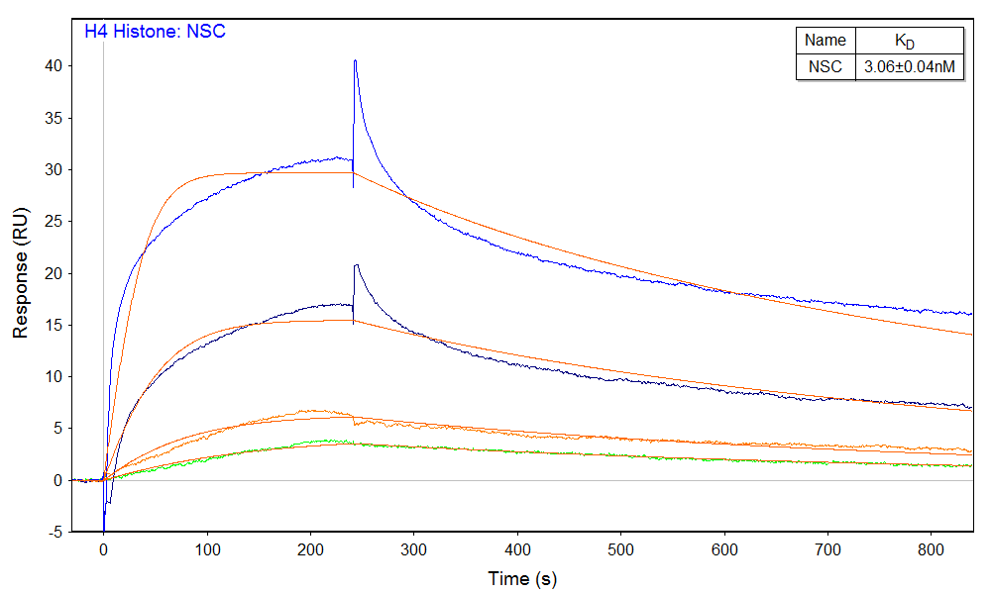
Figure 6 – Kinetic analysis of NSC binding calf thymus Histone (left) and H4 Histone (right).
Figures 3 – 6 show the binding responses of each aptamer binding the two Histone proteins. Color coding was used to illustrate the different analyte concentrations.

Table 1 – Kinetic rate constants for RNA aptamers binding Histone proteins
Analyte | Ligand | k_{a} (M⁻¹s⁻¹) | k_{d} (s⁻¹) | K_{D}
KU5 | Calf thymus Histone | 1.18±0.02e6 | 7.83±0.04e-4 | 663±9pM
KU7 |  | 1.62±0.03e5 | 9.15±0.06e-4 | 5.6±0.1nM
KU9 |  | 9.2±0.1e5 | 1.111±0.009e-3 | 1.21±0.02nM
NSC |  | 7.6±0.1e5 | 1.94±0.02e-3 | 2.56±0.04nM
KU5 | H4 Histone | 1.53±0.02e6 | 1.068±0.005e-3 | 698±8pM
KU7 |  | 5.62±0.05e5 | 2.25±0.01e-3 | 4.01±0.04nM
KU9 |  | 7.26±0.08e5 | 1.095±0.006e-3 | 1.51±0.02nM
NSC |  | 5.59±0.06e5 | 1.71±0.01e-3 | 3.06±0.04nM
Error values shown represent standard error from the model fit.

